**Patient Consent: Collection, Use and Disclosure of Personal Health and Financial Information**

Privacy of your personal health and financial information is an important part of our office providing you with quality dental care. We understand the importance of protecting your personal health and financial information. We are committed to collecting, using and disclosing your personal health and financial information responsibly. It is important to us to provide this service to our patients.

In this office. Dr. Kinson, Rydant, Kivinen and Wallace is the contact person for personal health information and financial related matters.

All staff members who come in contact with your personal health and financial information are aware of the sensitive nature of the information that you have disclosed to us. They are all trained in the appropriate uses and protection of your information.

We have outlined what our office is doing to ensure that:

* Only necessary information is collected about you;
* We only share your information with your consent;
* Storage, retention and destruction of your personal health and financial information complies with existing legislation, and privacy protection protocol
* Our privacy protocol comply with privacy legislation, standards of our regulatory body, the Royal College of Dental Surgeons of Ontario, and the law

Do not hesitate to discuss our policies with any member of Upper Gage Dental Centre.

By signing the consent section on Upper Gage Dental Centre’s medical form, you have agreed that you have given your informed consent to the collection, use and/or disclosure of your personal health and financial information for the purposes listed. If a new purpose arises for the use and/or disclosure of your personal health and financial information, we will seek your approval in advance.

Your personal health and financial information may be accessed by regulatory authorities under the terms of the Regulated Health Professions Act (RHPA) for the purposes of the Royal College of Dental Surgeons of Ontario fulfilling its mandate under the RHPA

You may withdraw your consent for use or disclosure of your personal health and financial information at any time.

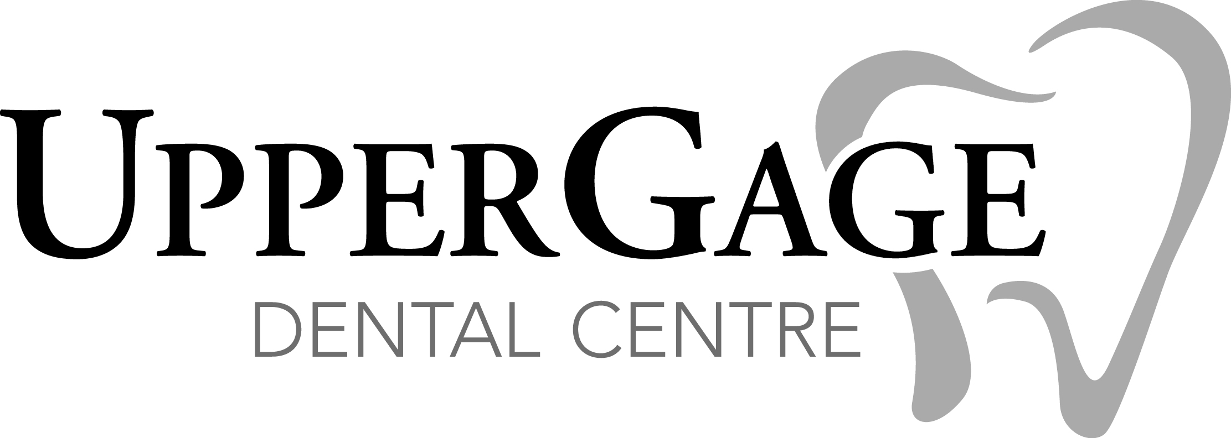

**How Our Office Collects, Uses and Discloses Patients’ Personal Health and Financial Information**

Our office understands the importance of protecting your personal health and financial information. To help you understand how we are doing that, we have outlined here our office is using and disclosing your information.

This office will collect, use and disclose personal health and financial information about you for the following purposes:

* To deliver safe and efficient patient care
* To identify and to ensure continuous high quality service
* To assess your health needs
* To provide health care
* To advise you of treatment options
* To enable us to contact you
* To establish and maintain communication with you
* Toto offer and provide treatment, care and services in relationship to the oral and maxillofacial complex and dental care generally
* To communicate with other treating health care providers, including specialists and general dentists who are the referring dentists and/or peripheral dentists
* To allow us to maintain communication and contact with you to distribute health care information and to book and confirm appointments
* To allow us to efficiently follow-up for treatment, care and billing
* For teaching and demonstrating purposes on anonymous basis
* To complete an submit dental claims for third party adjudication and payment
* Wo comply with legal and regulatory requirements , including the delivery of patients’’ charts and records to the Royal College of Dental Surgeons on Ontario in a timely fashion, when required, according to the provision of the Regulated Health Professions Act
* To comply with agreements/undertakings entered into voluntarily by the member with the Royal College of Dental Surgeons of Ontario, including the delivery and/or review of patent’s charts and records to the College in a timely fashion for regulatory and monitoring purposes
* To permit potential purchasers, practice brokers or advisors to evaluate the dental practice
* To allow potential purchasers, practice brokers or advisors to conduct an audit in preparation for a practice sale
* To deliver your charts and records to the dentist’s insurance carrier to enable the insurance company to assess liability and quantify damages, if any
* To prepare materials for the Health Professions Appeal and Review Board (HPARB)
* To invoice for goods and services
* To process credit card payments
* To collect unpaid accounts
* To assist this office to comply with all regulatory requirements
* To comply generally with the law