ABOUT YOU
Name: _________________________________ □ Female □ Male
Address: _____________________________________________
City: ____________________ Prov.: _____ Postal Code: _______
Home Phone: ______________ Bus. Phone: _________________
Cell Phone: ___________________________________________
Birth Date: Day______Month______ Year______
□ Single □ Married □ Widowed □ Minor
E-mail Address: ________________________________________
Name of Spouse: _______________________________________
Name of Children: ______________________________________
Health Card #: _________________________________________
Who can we thank for referring you: ________________________

EMERGENCY INFORMATION
Person to Contact: ______________________________________
Relationship: __________________________________________
Phone: _______________________________________________

INSURANCE INFORMATION
□ No Insurance Coverage.
□ I will be responsible for all charges to my dental account.
□ I have alternative dental coverage.
Insurance Company Name: _______________________________
Group#: ____________________ID#: ______________________
SIN #: _______________________________________________
Employer: ____________________________________________
Name of School or University if applicable: ___________________
If spouse is your policy holder or has second insurance:
Spouse’s Name: _______________________________________
Spouse’s Birth date: ____/____ /____ Spouse’s SIN#: __________
Spouse’s Employer: ____________________________________

DENTAL HISTORY

How do you feel your overall dental health is:
□ Excellent □ Good □ Fair □ Poor
Rate how regularly you have had your teeth cleaned:
□ 9 months □ 6 months □ 3 months □ Unknown
What is your level of sensitivity to dental procedures:
□ Low □ Moderate □ High
How do you feel about the look of your teeth:
□ Excellent □ Good □ Fair □ Poor
Date of your last hygiene visit____ /____ /____
Are you interested in having regular hygiene cleanings? □ yes □ no
Have you ever been treated for TMJ or TMJD? □ yes □ no

What is the main reason for your visit today? ______________
_____________________________________________________

Today’s Date: _______________
Pre-Clinical History
We are happy to have you join our great family of patients and friends. The benefits of a healthy, beautiful smile are immeasurable, and our goal is to allow you to obtain the healthy teeth and attractive smile you want and deserve. Please complete this form so that we can provide the best care possible for you. Thank you!
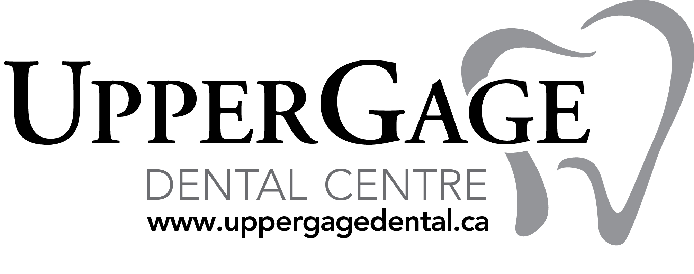
OVER →
MEDICAL HISTORY

Name of Physician: ______________________________________________________
Address: ___________________________________ Phone Number: ______________

Have you had any serious health problems in the last five years? □ yes □ no If yes, please explain: _________________________________________________________

Do you smoke? □ yes □ no □ quit
(For Women) Are you currently pregnant? □ yes □ no
Have you ever needed an antibiotic before a dental appointment? □ yes □ no

Please list prescription/supplemental medications: __________________________
______________________________________________________________________

Please check if you’re allergic to any of the following
□ Local anesthetics | □ Sulfa drugs | □ Codeine/other narcotics
□ Penicillin/other antibiotics | □ Aspirin | □ Latex sensitivity
□ Barbiturates, sedatives,  sleeping pills | □ Shellfish, iodine or red wine | □ Other __________________  ______________________

Do you have, or have you had, any of the following?
□ AIDS/HIV Positive | □ Drug Addiction | □ Hepatitis B or C | □ Rheumatism
□ Alzheimer’s Disease | □ Easily Winded | □ Herpes | □ Scarlet Fever
□ Anaphylaxis | □ Emphysema | □ High Blood Pressure | □ Shingles
□ Arthritis/Gout | □ Epilepsy or Seizures | □ Hives or Rash | □ Sickle Cell Disease
□ Artificial Heart Valve | □ Excessive Bleeding | □ Hypoglycemia | □ Sinus Trouble
□ Artificial Joint | □ Excessive Thirst | □ Irregular Heartbeat | □ Spina Bifida
□ Asthma | □ Fainting Spells/Dizziness | □ Kidney Problems | □ Stomach/Intestinal  Disease
□ Blood Disease | □ Frequent Cough | □ Leukemia | □ Stroke
□ Blood Transfusion | □ Frequent Diarrhea | □ Liver Disease | □ Swelling of Limbs
□ Breathing Problem | □ Frequent Headaches | □ Low Blood Pressure | □ Thyroid Disease
□ Bruise Easily | □ Genital Herpes | □ Lung Disease | □ Tonsillitis
□ Cancer | □ Glaucoma | □ Mitral Valve Prolapse | □ Tuberculosis
□ Chemotherapy | □ Hay Fever | □ Pain in Jaw Joints | □ Tumors or Growths
□ Chest Pains | □ Heart Attack/Failure | □ Parathyroid Disease | □ Ulcers
□ Cold Sores/Fever  Blisters | □ Heart Murmur | □ Psychiatric Care | □ Venereal Disease
□ Congenital Heart  Disorder | □ Heart Pace Maker | □ Radiation Treatments | □ Yellow Jaundice  □ ADD/ADHD
□ Convulsions | □ Heart Trouble/Disease | □ Recent Weight Loss | □ Depression
□ Cortisone Medicine | □ Hemophilia | □ Renal Dialysis | □ Anxiety Disorders
□ Diabetes | □ Hepatitis A | □ Rheumatic Fever

Have you ever had any serious illness not listed above? If yes, please explain: _______
______________________________________________________________________

I agree to be responsible for all charges for dental services and materials not paid by my dental benefit plan, unless the treating dentist has a contractual agreement with my plan prohibiting all or a portion of such charges, to the extent permitted under applicable law. I authorize release of information relating to this claim. I also authorize payment of dental benefits, otherwise payable to me, to be paid directly to Upper Gage Dental Centre.

Signature ______________________________________ Date________________
I agree that Upper Gage Dental Centre can collect, use and disclose personal health information about myself as set out in the information about the office privacy’s policies.

